Business Rules

Description
This document explains the configuration of UI Policies used to control dynamic form behaviour in the ServiceNow Service Catalog. These rules ensure that additional fields are displayed or hidden based on user selections, improving data accuracy and user experience without relying on complex scripts.

Purpose
- Enforce conditional visibility of form fields
- Reduce incomplete or incorrect submissions
- Improve usability through dynamic form behaviour
- Maintain clean and script-free configurations using UI Policies

UI Policy Scenario
Condition:
If the user selects “Others” in the Types of Devices field, then the “Please specify” field should be displayed.

Configuration Details
Catalog UI Policy Setup
- Navigate to Service Catalog > Maintain Items
- Open the Network Request catalog item
- In the related list, locate Catalog UI Policies
- Click New to create a UI Policy
- Configure the following:
  - Applies to: Catalog Item
  - Catalog Item: Network Request
  - Short Description: Show the specified field when the device is Others
- Set the condition:
  - Types of Devices are Others
- Click Save

UI Policy Action Configuration
- After saving the UI Policy, go to UI Policy Actions (related list)
- Click New
- Select the variable:
  - Please specify
- Set:
  - Visible: True
- Save the UI Policy Action
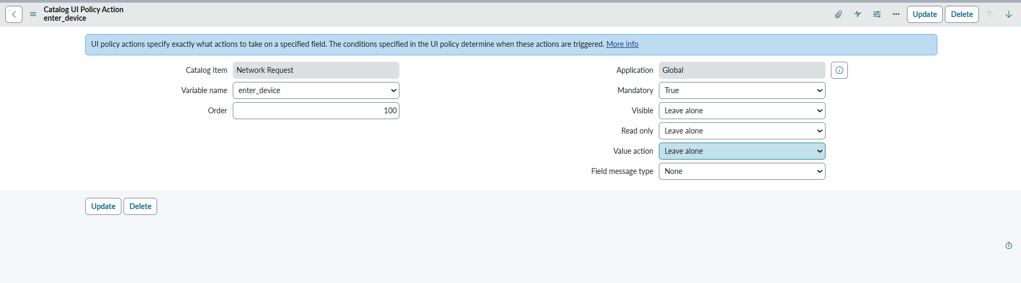

Testing & Validation
- Open the Network Request catalog item in the Service Portal
- Select Others under Types of Devices
- Verify that the Please specify field becomes visible
- Change selection to other options and confirm the field hides automatically

Outcome
- Dynamic form behaviour achieved without client scripts
- Improved user guidance and cleaner data capture
- Reduced configuration complexity and maintenance effort
